ANALOGUE – UNIVERSAL TESTING MACHINES (TUN)  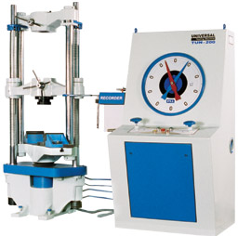  CAPACITY : 100KN to 2000KN | COMPUTERIZED Universal TESTING MACHINE (TUE-C)  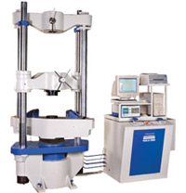  CAPACITY : 100KN to 2000KN | Analogue Cum Computerised- UNIVERSAL TESTING MACHINES(TUE-CN)  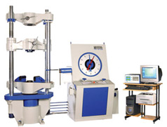  CAPACITY : 100KN to 2000KN
FRONT OPEN, HYDRAULIC GRIPS  ( UTM )  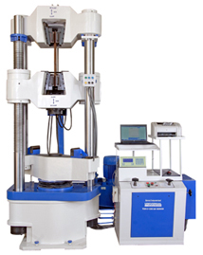  CAPACITY : 400KN to 2000KN | ANALOGUE TENSILE TESTING MACHINE (TKG)  CAPACITY : 200N to 50KN | Electronic /COMPUTERIZED TENSILE TESTING MACHINE (TKG-E/TKG-EC)  CAPACITY : 200N to 50KN
Computer Controlled Ball Screw Driven Universal Testing Machine (M)  CAPACITY : 1KN to 100KN | BEND & RE BEND TESTING MACHINE  (FBR)  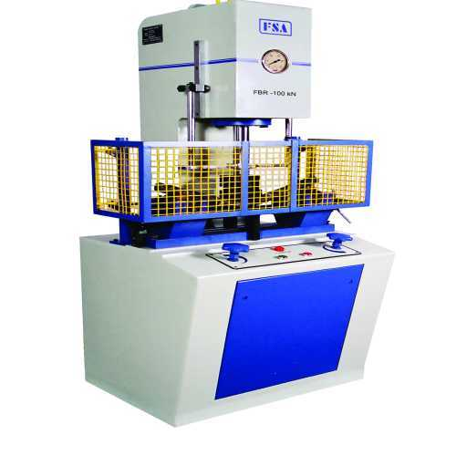  CAPACITY : 100KN to 150KN | ANALOGUE COMPRESSION TESTING MACHINES (FCT)  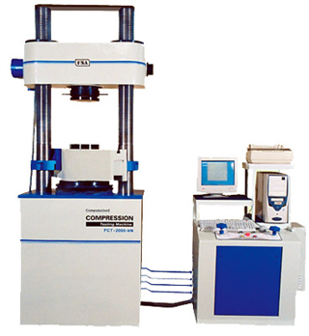  CAPACITY : 500KN to 3000KN
Horizontal Chain and Rope Testing Machine (FCR)  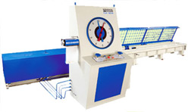  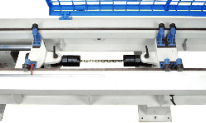  CAPACITY : 100KN to 3000KN | COIL SPRING TESTING MACHINES (STM)  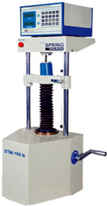  CAPACITY : 60KN to 2000N | LEAF SPRING TESTING MACHINES (FST)  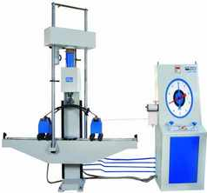  CAPACITY : 100KN to 500KN

